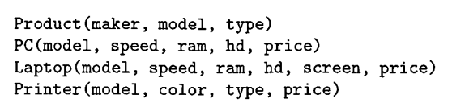

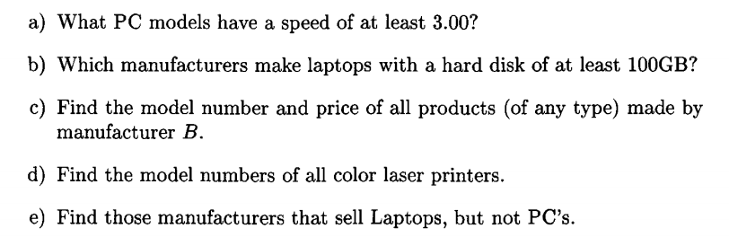

f) Find those hard- disk sizes that occur in two or more PC’s

a) πmodel(σspeed >= 3.00 (PC))

b) πmaker(σhd >= 100(Laptop ⋈ Product))

c) πmodel,price (σmaker=’B’(Product ⋈ ( PC **∪ Laptop**  **∪ Printer**  )))

d) πmodel (σtype=’laser’ ^ color =’color’ (**Printer**))

e) πmaker (Product - πmaker(σtype=’pc’ (**Product**)) ⋈ Laptop)

